13TH

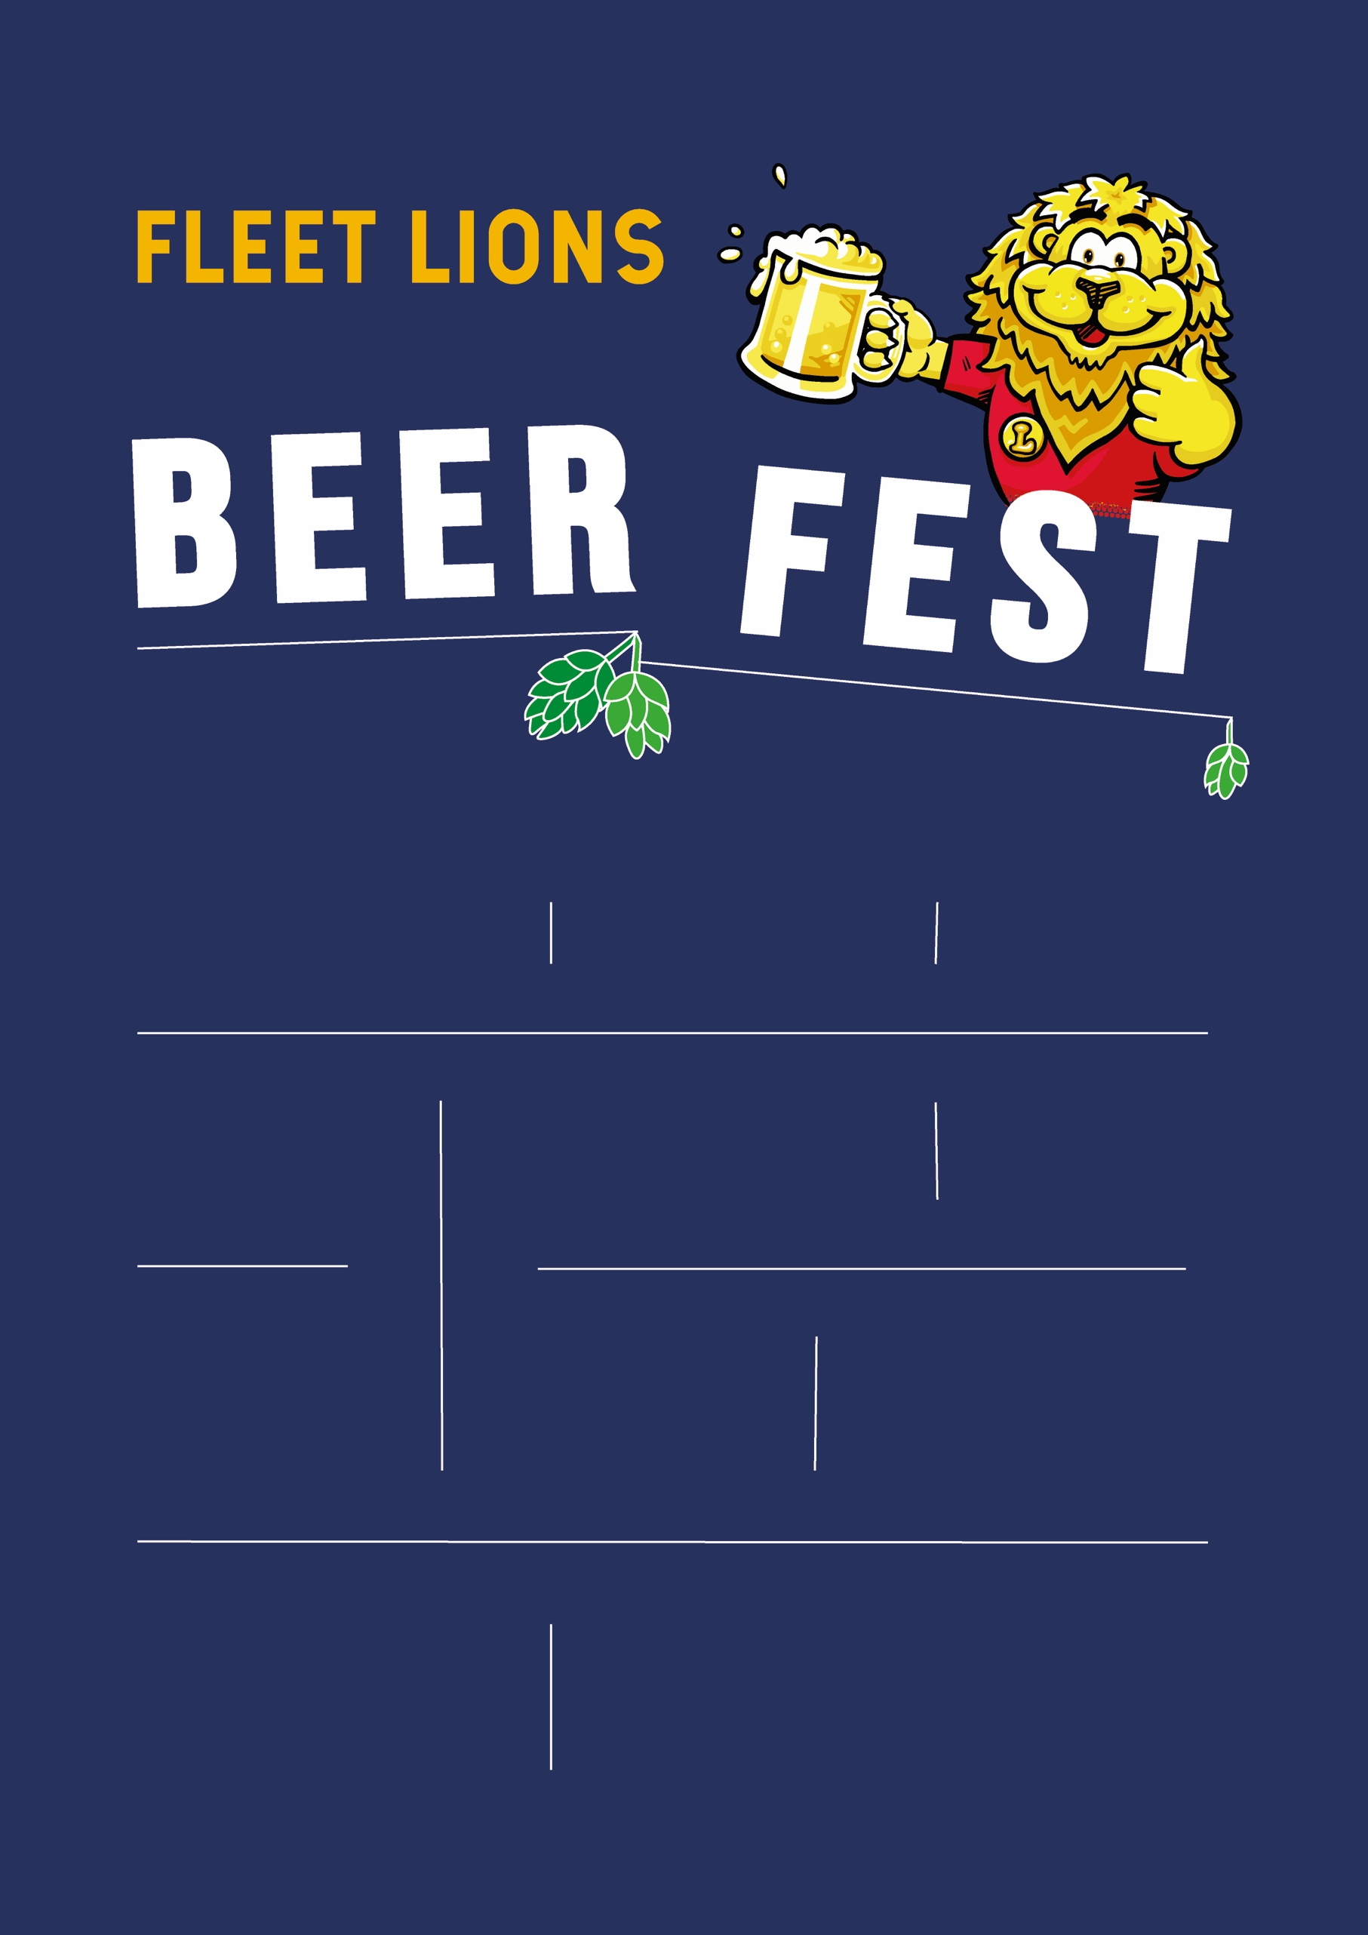

Raising money for local causes

SERVING OUR c0mmunity fOr 50 YEARS

BRING YOUR OWN GLASS. We’re glassless to help the environment

BEERFEST@FLEETLIONS.ORG.UK

[FLE](http://WWW.FLE/)ETLIONS.ORG.UK/BEERFEST

CIO 1177181

THIS IS A GLASSLESS

& CASHLESS EVENT

The Harlington, 239 Fleet Road, Fleet, Hampshire GU51 4BY

Lunchtime/evening tickets £16 Includes four drinks tokens

GREAT MUSIC

HOT

FOOD

OVER 40

REAL ALES

& CIDERS

Supported by:

 

15 MINUTE WALK FROM FLEET TRAIN STATION

SATURDAY 3RD AUGUST

Two sessions: 11-3PM &

5:30-9:30PM

16TH ANNUAL EVENT